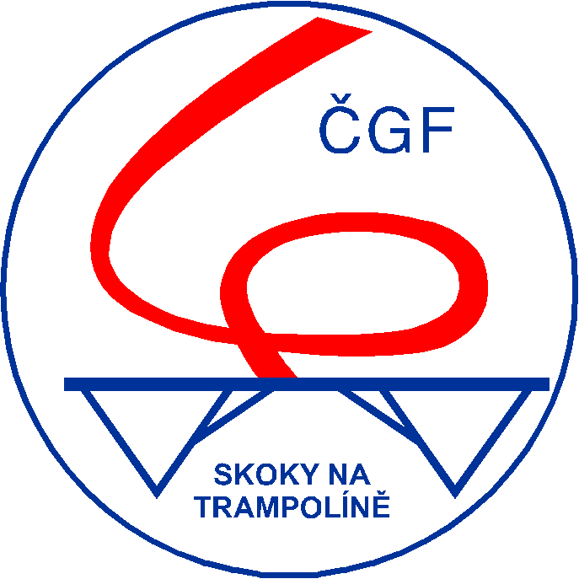
CZECH GYMNASTICS FEDERATION

Trampoline Technical Committee

32nd International Trampoline Competition of Friendship

(Youth Olympic Hopefuls Competition)

Kladno, Czech Republic, September 2004, 4th

I N V I T A T I O N

Prague 05.06.2004

KT/046/04

Dear sport friends,

I have the pleasure in sending to your federation / club this invitation for the

32nd Annual International Trampoline Competition of Friendship.

The competition will take place on Saturday September 4th, 2004 in the city of Kladno what is situated close to the Czech capital Prague in the distance of only 20 km.

The individual and synchronised competitions are designed not only for the senior trampoline competitors, who can choose the FIG A or FIG B level, but even for the youth competitors 12-17 years of age with the FIG B performance level. We consider this fact for a good chance to test your Olympic hopefuls in the conditions of international event.

We would be pleased to welcome your team at the occasion of the traditional annual event in our country.

Enclosed you find the Regulations with all organisational and technical details.

Best regards

Vladimír Z e m a n
ČGF TRA-TC Chair

R e g u l a t i o n s
32nd International Trampoline Competition of Friendship 2004, Czech Republic
(Youth Olympic Hopefuls Competition)

- Organiser
Czech Gymnastics Federation, Trampoline TC with local clubs
Contact : Atletická 100/2, P.O.Box 40, 160 17 Praha 6, Czech Republic
Phone / Fax : (+ 420) 257 210 811
E-mail : cgf@cstv.cz, trampoliny@cstv.cz
Website : http://trampoliny.cstv.cz

- Date : Saturday, September 2004, 4th

- Venue
Sport Hall Kladno, Sportovců 817, Kladno, Czech Republic

- Competitions
a) Individual competitions (TRI)
- seniors ladies 17 years and older (born 1987 and before)
- seniors men 17 years and older (born 1987 and before)
- juniors girls 12-17 years (born 1987-1992)
- juniors boys 12-17 years (born 1987-1992)
b) Synchronised competitions (TRS)
- seniors ladies 17 years and older (born 1987 and before)
- seniors men 17 years and older (born 1987 and before)
- juniors girls 12-17 years (born 1987-1992)
- juniors boys 12-17 years (born 1987-1992)
Notes :
- 17 year old competitors / pairs can participate either in seniors or in juniors only
- in synchronised senior competitions also the senior / junior mix pairs are allowed
- in the case of small number of participants in the senior / junior category the organiser is allowed to merge the senior & junior categories (nevertheless the best juniors / junior pairs can be also awarded)

- Participation
Competitors from the FIG affiliated federations and/or their clubs in good standing may participate.

- Judges
All participating delegations are asked to provide at least one judge with a valid FIG brevet.
1/3

- Technical regulations
Valid FIG Trampoline Code of Points and valid FIG A & FIG B requirements for first routine will be applied. Ten finalists (including at least one competitor / pair from the host Czech federation in each category), all three routines will be counted.
Routines :
- Seniors : FIG A or FIG B compulsory requirements (FIG B with difficulty restriction - max. 7,5 pts. in voluntary / final routine will be counted)
- Juniors : FIG B requirements
The Qualifying Round in the groups, each group performs their first and second voluntary routine prior the next group will be starting (§ 1.2.4).

- Equipment
2 Eurotramp Trampolines with 6x4 mm beds

- Preliminary time schedule
Friday, September 3rd
Arrivals to Kladno or Prague
16.00 - 21.00 open training
21.00 meeting - officials, judges
Saturday, September 4th
08.00 - 12.00 training
12.00 - 16.00 preliminaries
17.00 - 19.00 finals
20.30 - 01.00 closing evening party
Sunday, September 5th
Departures from Kladno or Prague
Definitive time schedule will be handed out upon arrival.

- Entry fees
Entry fee per competitor : EUR 15,- (no additional fee for TRI+TRS)
Entry fees are non-refundable in case of cancellations.

- Accommodation
Package A : 2 nights with breakfast in *** hotel, dinner on Friday, lunch and closing party incl. dinner on Saturday, hotel - venue transfers, Prague airport/bus/railway arrival/departure transfers. Prices for whole stay (2 nights) per person :
in single room ………… 135,- EUR
in double room ………… 110,- EUR
in double room + extra bed ………… 90,- EUR
Package B : 2 nights without breakfast in hostel (bathroom/WC in room is not guarranted), closing party incl. dinner on Saturday.
Price for whole stay (2 nights) : ………… 40,- EUR
Cancelation : 50 % of stay costs will be refunded in case of cancellation which will be made 01.-25.08.2004, no refunds will be made in case of cancellation after 25.08.2004. (Entry fees are non-refundable in any case of cancellation.)
2/3

- Transportation
The Organising Committee will provide the transportation from/to the Prague airport/bus/railway station and between hotel and competition venue for all those who selected the Accommodation Package A and have advised their arrival and departure schedule with the Nominative Entry.

- Entries deadlines
Declaration of interest : 30.06.2004

Definitive entry : 31.07.2004

Nominative entry : 25.08.2004
Organising Committee : Fax : (+ 420) 257 210 811

- Payment
Payment (entry fees + stay costs) deadline is 31.07.2002 and the payment will have to be transferred to :
GE Capital Bank, Vítězné náměstí 2, Praha 6
Account No. 1724809-504/0600
IBAN CZ64 0600 0000 0017 2480 9504
BIC / SWIFT AGBACZPP
for Czech Gymnastics Federation, Atletická 100/2, P.O.Box 40, 160 17 Praha 6
Please note that your federation / club is responsible for covering all bank fees in connection with bank transfers.

- Insurance
The Organising Committee and the Czech Gymnastic Federation can not be held responsible for any liabilities in the case of accidents, illness and the like. Therefore, all competitors and officials must make their own arrangements for an appropriate insurance (health, accident, etc.).

- Miscellaneous
For the additional services (visa, additional accommodation, special travel arrangements, Prague sightseeing etc.) do not hesitate contact us, please.
There is the regular public transport Kladno - Prague bus stop in the front of the main official hotel (ca 30 min. journey duration).

Vladimír Z e m a n
ČGF TRA-TC Chair
3/3

DECLARATION of INTEREST

32nd International Trampoline Friendship Cup

Kladno, Czech Republic, September 2004, 4th

Send to : Czech Gymnastic Federation Deadline : 30th June 2004
Fax : (+ 420) 257 210 811

Federation / Club :
Address :
Phone, Fax, E-mail :
Contact person :

supposes to participate with following number of persons :

competitors | judges | officials | tourists | TOTAL

Competitors / pairs : | TRI Ladies | TRI Men | TRS Ladies | TRS Men
Seniors 17 and older
Juniors 12-17

and supposes to use following accommodation service :

Accommodation : | Package A | Package A | Package A | Package B | persons
Persons in
 | Single room | Double room | Double+extra | Hostel | TOTAL

Place and date |  | Signature

DEFINITIVE ENTRY

32nd International Trampoline Friendship Cup

Kladno, Czech Republic, September 2004, 4th

Send to : Czech Gymnastic Federation Deadline : 31st July 2004
Fax : (+ 420) 257 210 811

Federation / Club :
Address :
Phone, Fax, E-mail :
Contact person :

competitors | judges | officials | tourists | TOTAL

Competitors / pairs : | TRI Ladies | TRI Men | TRS Ladies | TRS Men
Seniors 17 and older
Juniors 12-17

Accommodation : | Package A | Package A | Package A | Package B
Price per person | 135,- EUR | 110,- EUR | 90,- EUR | 40,- EUR | x
x persons in
= stay costs (EUR)
 | Single room | Double room | Double+extra | Hostel | TOTAL

Total costs : |  | x | 15,- | = |  | + |  | =
 | competitors |  | EUR |  | Entry fee |  | Accommodation |  | TOTAL EUR

to be transferred to :
GE Capital Bank, Vítězné náměstí 2, Praha 6
Account No. 1724809-504/0600
IBAN CZ64 0600 0000 0017 2480 9504
BIC / SWIFT AGBACZPP
for Czech Gymnastics Federation, Atletická 100/2, P.O.Box 40, 160 17 Praha 6
Please note that your federation / club is responsible for covering all bank fees in connection with bank transfers.

Place and date |  | Signature

NOMINATIVE ENTRY

32nd International Trampoline Friendship Cup

Kladno, Czech Republic, September 2004, 4th

Send to : Czech Gymnastic Federation Deadline : 25th August 2004
Fax : (+ 420) 257 210 811

Federation / Club :
Address :
Phone, Fax, E-mail :
Contact person :

Arrival schedule |  |  |  | Departure schedule
Date : |  | Time : |  | Date : |  | Time :
By : |  | Flight/Line: |  | By : |  | Flight/Line:

Officials : | Last name First name | Male/Female
Head of delegation :
Judge :
Coach :

Competitors - Trampoline individual (TRI) :
No. | Sen/Jun | Last name | First name | Birth date | Male/Female
1.
2.
3.
4.
5.
6.
7.
8.
9.
10.

Federation / Club :

TRI - cont. :
No. | Sen/Jun | Last name | First name | Birth date | Male/Female
11.
12.
13.
14.
15.

Pairs - Trampoline synchronised (TRS) :
No. | S/J | Last name First name | Birth | Last name First name | Birth | M/F
1.
2.
3.
4.
5.
6.
7.
8.
9.
10.

Tourists :
No. | Last name First name | M/F | No. | Last name First name | M/F
1 |  |  | 6
2 |  |  | 7
3 |  |  | 8
4 |  |  | 9
5 |  |  | 10

Place and date |  | Signature

